**Trabajo de Ingles-Escuela PrivadaTaragüi**

**Actividades de Ingles**

**6to año**

**Contenidos a trabajar: Presente Simple / Adverbios de Frecuencia / Reading ”Daily Routine” /**“**Our DNA is unique”**

**Entrega del trabajo hasta el 3 de abril (a más tardar)**

* Les dejo en esta primera hoja un resumen del Presente Simple para que vuelvan a repasar este tema, en la siguiente hoja tienen dos ejercicios de este tiempo para aplicar la teoría.
* Luego tienen dos textos para leer, en el primero deben marcar el verdadero o falso, después deben escribir sobre un día de la semana siguiendo lo que dice la consigna del punto dos.
* El otro texto es de un tema distinto y tienen tres actividades que realizar; el primer ejercicio es para acomodar las palabras, el siguiente es elegir si la oración es verdadera o falsa según lo que leyeron y la última actividad es un escrito para realizar sobre que significa una vida saludable para ustedes explicando sus razones.
* Por cualquier consulta recuerden que en la página de la escuela esta mi correo
* Dejo también un código para la aplicación ***Google Classroom***, así también si tienen dudas o consultas me comunican por ese medio: **nzorruu**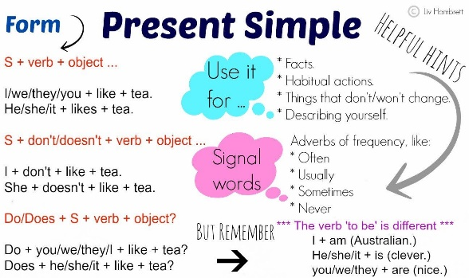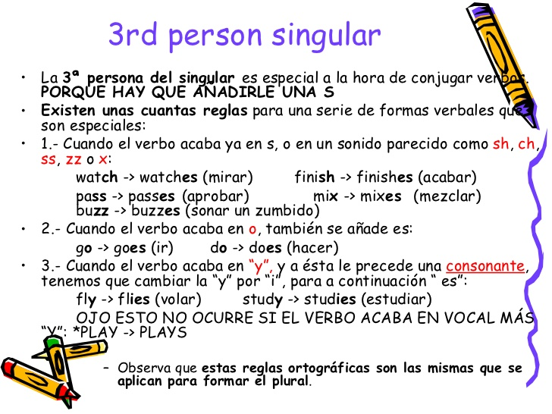

**Grammar: Present Simple**

**1.Change the following sentences into the negative, affirmative or interrogative forms.**

1 Joanna likes pets. (int.)

_______________________________

2 Do the boys go to school at 7:00 a.m.? (neg.)

__________________________________

3 George doesn’t go kayaking at weekends. (aff.)

__________________________________

4 Does your best friend study French? (aff.)

__________________________________

5 Pam and Sandra chat online every day. (int.)

____________________________________

**2.Fill in the blanks using the verbs in brackets in the Simple Present.**

*Ted:* I [1]________________________ (not want) to exercise today. I’m really tired, Pat.

*Pat:* How often [2]_______________ you_______________(train) for the school marathon?

*Ted:* I do physical activity every day. On Mondays and Wednesdays, I [3] ________________(have) tennis lessons after school. And then I [4]_______________________(ride) my bike to the gym. Sometimes a friend of mine [5]_____________________ (drive) me there in his car. The rest of the days, I [6] ________________________(go) swimming and running. What about you? Are you

training for the school marathon?

*Pat:* Are you crazy? I [7] _______________________(not do) any exercise at all! I [8] _____________________________(not like) sports. I just go to PE classes at school. That’s all I do. And I often skip many PE lessons.

*Ted:* So you [9]_________________________ (not enjoy) PE classes then

**Reading: Daily Routine**

**1.Read about Susan’s daily routine and write true (T) or false (false). Correct the false sentences.**

*I work in a computer store on weekdays from nine to five. So, I spend most of the day in the shop. At midday, I have lunch with my workmates. We usually go out for lunch and relax for a while. Sometimes, one of the girls I work with*

*brings little cakes or home-made cookies and we have them for dessert. Our break lasts an hour and we like going to the park on sunny days. I enjoy reading books there because I hardly ever read at home. As I live near my workplace, I often ride my bike to go to work and do some exercise at the same time (I don’t waste time waiting for the bus). When I’m not tired, I meet my friends after work and we often go to the shopping centre together.*

*My best friend is very fashionable and she always gives me some useful casual dress tips. In the evening, I usually make dinner because I love cooking and eating healthy food. After dinner, I go to bed and watch TV. I don’t usually sleep late at night and I rarely watch a complete film before falling asleep.*

*What about you? What’s your daily routine like?*

1. Susan works from Monday to Friday. [ ]
2. She doesn’t have lunch at home. [ ]
3. One of her workmates always brings something for dessert. [ ]
4. Susan never reads. [ ]
5. She goes to work by bike. [ ]
6. She has some free time at noon. [ ]
7. She doesn’t enjoy cooking. [ ]
8. Her best friend helps her buy new clothes. [ ]
9. Susan likes eating junk food. [ ]
10. She usually falls asleep when she’s watching TV. [ ]

**2.Write about a day of the week you particularly hate. Describe what you usually do on this day and explain why you don’t like it. Write a paragraph of 150-200 words**

**Reading: Our DNA is unique**

Some people have got blue eyes and others have got brown eyes. Some have got brown hair and others have got red hair. Our skin can be of different colours, and we haven’t got all the same weight or height. Why are we different? The answer is in our genes.

All humans get DNA from their parents. DNA is a molecule that can carry information. DNA can form genes, genes form chromosomes, and chromosomes form genomes. Genomes are unique instructions for life. Some scientists say that people can have more than one genome. For example, mothers can carry their children’s genomes.

Your genomes have got information about the colour of your hair and eyes. They say how tall you can be. Many genes can’t change, but some can change with time. Others can change because of the environment. We can help our genes by having healthy lives!

*Glossary*

**genes:** pieces of genetic information

**carry:** have got

**environment:** the area or circumstances around a person

**1.Read and unscramble the words.**

1. AND= DNA 2. gomeen= 3. gnee= 4. commerosho=

**2.Read and circle T (True) or F (False).**

1. Everyone has got the same skin colour. T - F

2. A person’s height can come from their DNA. T - F

3. All people can get DNA from their friends. T - F

4. Genomes are like instructions for life. T - F

5. Genomes can’t carry information about hair colour. T - F

6. Some genes can change with time. T - F

7. Having a healthy life can help your genes. T - F

**3.Stop and Think! What is a healthy life to you? Write a paragraph of 100-150 words**